AceAI – SMART AI-POWERED BADMINTON BIOMECHANICAL COACHING
& REAL-TIME STROKE ANALYTICS SYSTEM
DESIGN THINKING PROJECT  Nov/Dec 2026 |  | DESIGN THINKING AND INNOVATION PROJECT REPORT SUBMITTED IN PARTIAL FULFILLMENT OF REQUIREMENTS FOR THE AWARD OF THE  DEGREE OF BACHELOR OF ENGINEERING  IN COMPUTER SCIENCE AND ENGINEERING  OF THE ANNA UNIVERSITY
 |  | 
 |  | Submitted by  ABHISHEIK RAJA S T - 722825104001
  PROJECT
  WORK
BATCH
2025 – 2029
Under the Guidance of
Mr.B.Saravanan
Assistant Professor
COMPUTER SCIENCE AND ENGINEERING
 | Sri Eshwar College of Engineering  (An Autonomous Institution)  Kinathukadavu (Tk), Coimbatore - 641 202, Tamil Nadu  Approved by AICTE, New Delhi and Affiliated to Anna University, Chennai |  |  | 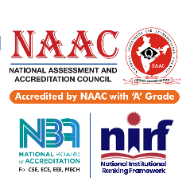
AceAI – SMART AI-POWERED BADMINTON BIOMECHANICAL COACHING
& REAL-TIME STROKE ANALYTICS SYSTEM
DESIGN THINKING PROJECT  Nov/Dec 2026 |  |  | DESIGN THINKING AND INNOVATION PROJECT REPORT SUBMITTED IN PARTIAL FULFILLMENT OF REQUIREMENTS FOR THE AWARD OF THE  DEGREE OF BACHELOR OF ENGINEERING  IN COMPUTER SCIENCE AND ENGINEERING  OF THE ANNA UNIVERSITY
 |  |  | Submitted by  ABHISHEIK RAJA S T - 722825104001
  PROJECT
  WORK
BATCH
2025 – 2029
Under the Guidance of
Mr.B.Saravanan
Assistant Professor
COMPUTER SCIENCE AND ENGINEERING

Sri Eshwar College of Engineering
(An Autonomous Institution)
Kinathukadavu (Tk), Coimbatore - 641 202, Tamil Nadu
Approved by AICTE, New Delhi and Affiliated to Anna University, Chennai
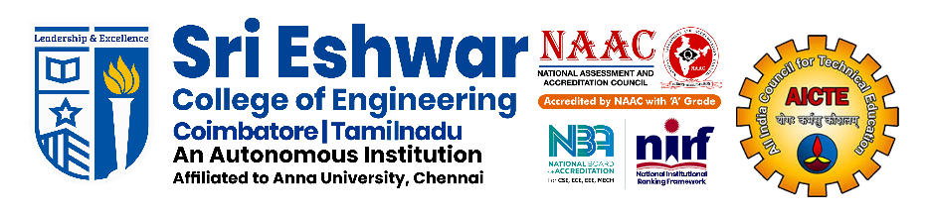

BONAFIDE CERTIFICATE

Certified that this Report titled “AceAI – Smart AI-Powered Badminton Biomechanical Coaching & Real-time Stroke Analytics System” is the bonafide work of
ABISHEIK RAJA S T | 722825104001

who carried out the project work under my supervision.

----------------------------------------- | -----------------------------------------
SIGNATURE | SIGNATURE
Dr.R.Subha M.E.,Ph.D.  HEAD OF THE DEPARTMENT  Computer Science and Engineering,  Sri Eshwar College of Engineering,  Coimbatore – 641 202. | Mr.B.Saravanan, M.E., Ph.D.,  SUPERVISOR  Assistant Professor,  Department of CSE,  Sri Eshwar College of Engineering,  Coimbatore – 641 202.

Submitted for the Autonomous Semester End Examination for Design Thinking and Innovation Project Viva-Voce held on ………………….

_________________________  INTERNAL EXAMINER | _________________________  EXTERNAL EXAMINER

QUALITY POLICY
To establish a system of Quality Enhancement, which would on a continuous basis evaluate and enhance the quality of teaching – learning, research and extension activities of the institution, leading to improvements in all processes, enabling the institution to attain excellence.

INSTITUTE VISION
To be recognized as a premier institution, grooming students into globally acknowledged engineering professionals.

INSTITUTE MISSION
- Providing outcome and value-based engineering education
- Nurturing research and entrepreneurial culture
- Enabling students to be industry ready and fulfill their career aspirations
- Grooming students through behavioral and leadership training programs
- Making students socially responsible

DEPARTMENT OF COMPUTER SCIENCE AND ENGINEERING

DEPARTMENT VISION
- To groom students into globally competent software professionals and meet the ever changing requirements of the industry.
DEPARTMENT MISSION
- Creating a quality academic environment with relevant IT infrastructure and empowering faculty and students with emerging technologies.
- Motivating staff and students to actively involve in lifelong learning and fostering research.
- Inculcating leadership and entrepreneurship skills in students.
- Generating opportunities for students to evolve as competent software professionals with societal consciousness.
PROGRAM EDUCATIONAL OBJECTIVES
PEO1: Graduates will build successful careers in computing and information technology domains by applying strong foundations in engineering principles, computer science fundamentals, and professional best practices.
PEO2: Graduates will pursue higher education, research, and entrepreneurial endeavours by demonstrating self-directed and life-long learning capabilities to continuously adapt to emerging technologies, industry trends, and societal needs.
PEO3: Graduates will conceive, design and implement innovative, and ethically responsible computing solutions to address real-world challenges in industry and society.

PROGRAM OUTCOMES

PO1: Engineering Knowledge: Apply knowledge of mathematics, natural science, computing, engineering fundamentals and an engineering specialization as specified in WK1 to WK4 respectively to develop to the solution of complex engineering problems.
PO2: Problem Analysis: Identify, formulate, review research literature and analyze complex engineering problems reaching substantiated conclusions with consideration for sustainable development. (WK1 to WK4)
PO3: Design/Development of Solutions: Design creative solutions for complex engineering problems and design/develop systems/components/processes to meet identified needs with consideration for the public health and safety, whole-life cost, net zero carbon, culture, society and environment as required. (WK5)
PO4: Conduct Investigations of Complex Problems: Conduct investigations of complex engineering problems using research-based knowledge including design of experiments, modelling, analysis & interpretation of data to provide valid conclusions. (WK8).
PO5: Engineering Tool Usage: Create, select and apply appropriate techniques, resources and modern engineering & IT tools, including prediction and modelling recognizing their limitations to solve complex engineering problems. (WK2 and WK6)
PO6: The Engineer and The World: Analyze and evaluate societal and environmental aspects while solving complex engineering problems for its impact on sustainability with reference to economy, health, safety, legal framework, culture and environment. (WK1, WK5, and WK7).
PO7: Ethics: Apply ethical principles and commit to professional ethics, human values, diversity and inclusion; adhere to national & international laws. (WK9)
PO8: Individual and Collaborative Team work: Function effectively as an individual, and as a member or leader in diverse/multi-disciplinary teams.
PO9: Communication: Communicate effectively and inclusively within the engineering community and society at large, such as being able to comprehend and write effective reports and design documentation, make effective presentations considering cultural, language, and learning differences
PO10: Project Management and Finance: Apply knowledge and understanding of engineering management principles and economic decision-making and apply these to one’s own work, as a member and leader in a team, and to manage projects and in multidisciplinary environments.
PO11: Life-Long Learning: Recognize the need for, and have the preparation and ability for i) independent and life-long learning ii) adaptability to new and emerging technologies and iii) critical thinking in the broadest context of technological change. (WK8)

PROGRAM SPECIFIC OUTCOMES
PSO1: Demonstrate knowledge in open-source technologies.
PSO2: Develop innovative solutions by adapting emerging technologies for industry-oriented applications.
PSO3: Implement SDLC principles for project/product development.

